Daffodil Fuel Station Management System

Complete User Guide (Updated)

Table of Contents
- Introduction
- Getting Started
- Dashboard Overview
- Point of Sale (POS)
  - Fuel Sales (Liters)
  - CNG Sales (Cubic Meters)
  - Normal Item Sales
  - Amount-Based Selling
- CNG Pipeline Management
- Inventory Management
- Accounting Module
- Financial Reports
- Payroll & HR
- Rental Management
- Customer Management
- System Settings
- Reports & Export
- Troubleshooting

Introduction

Welcome to DSL Fuel Station Management System
This comprehensive system is designed to manage all aspects of your fuel station operations including:
- Point of Sale (POS) - Fast and efficient fuel, CNG, and item sales
- CNG Pipeline Management - Track government-supplied CNG with meter readings
- Flexible Selling Options - Sell by liter, cubic meter, or amount (BDT)
- Inventory Management - Track fuel stock in real-time
- Accounting - Complete financial management
- Payroll - Employee salary and attendance management
- Rental Management - Shop rental income tracking
- Customer Management - Credit sales and customer ledger
- Reporting - Comprehensive business reports

CNG Sales Overview
CNG (Compressed Natural Gas) is supplied through government pipeline with meter readings. The system handles:
- Pipeline Meter Reading: Track incoming CNG from government supply
- Sales Meter Reading: Track CNG dispensed to customers
- Unit Measurement: Cubic Meters (m³) instead of liters
- Loss Calculation: Pipeline leakage and wastage tracking

Selling Options Available
Selling Method | Description | Example
Liters | Sell by volume | 10 Liters Diesel
Cubic Meters (CNG) | Sell by volume for CNG | 5 m³ CNG
Amount (BDT) | Sell by value | Give me 2000 Taka fuel

Getting Started

1. Login to the System
- Open your web browser
- Navigate to the system URL
- Enter your credentials:
  - Username: Your assigned username
  - Password: Your assigned password
- Click the "Login" button

2. First Time Login

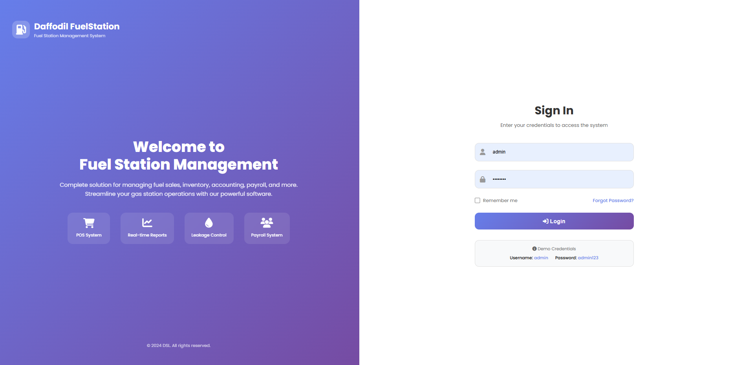
Default Credentials:
- Username: admin
- Password: admin123
Important: Change your password immediately after first login.

3. Navigation
The system uses a left sidebar navigation menu:
- Dashboard - Overview of key metrics
- POS - Process fuel, CNG, and item sales
- CNG Management - Pipeline meter readings
- Inventory - Manage stock
- Accounting - Financial management
- Reports - Generate reports
- Settings - System configuration

Dashboard Overview

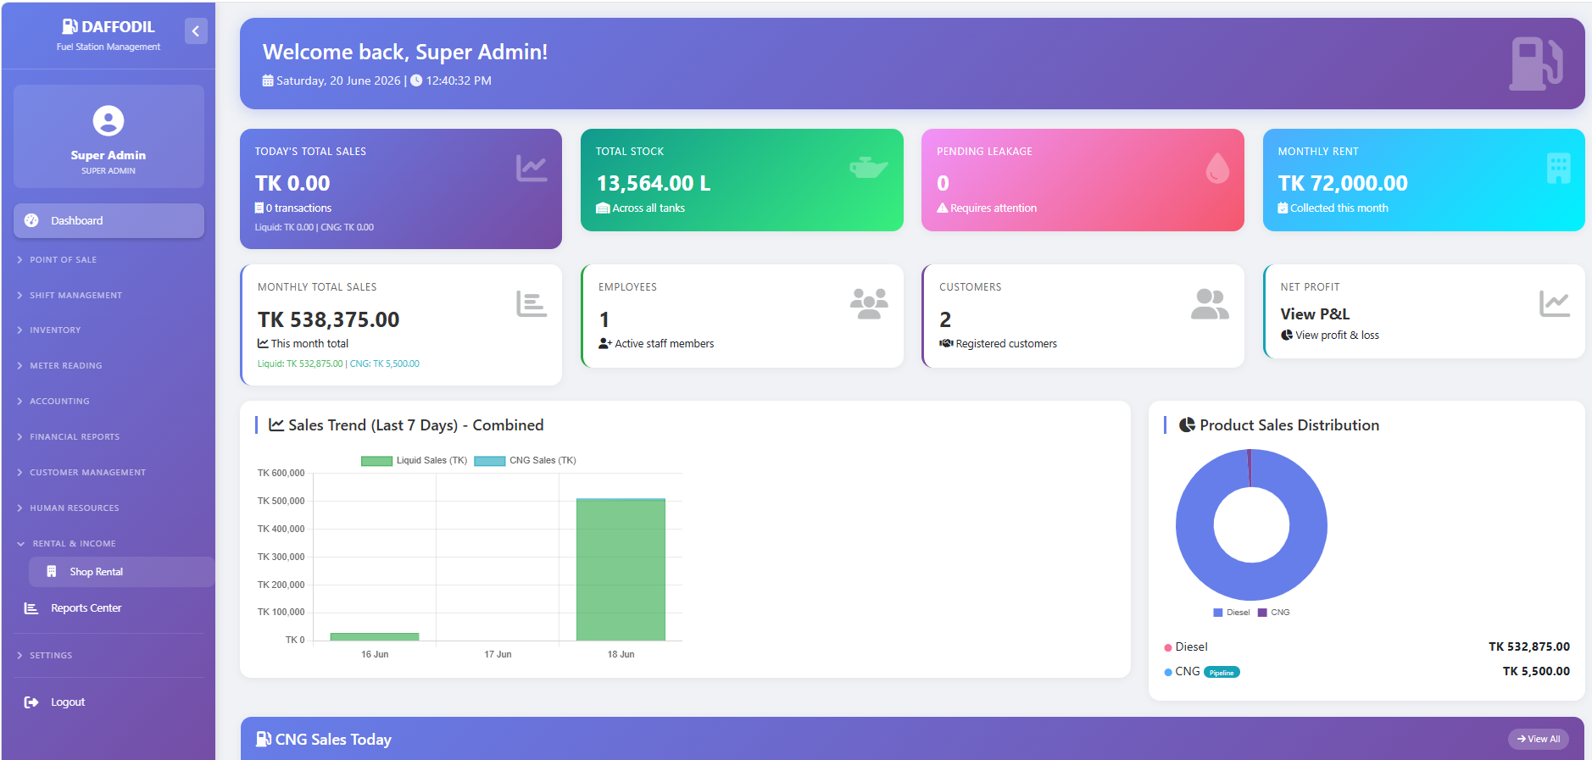

Dashboard Components

1. Statistics Cards
Card | Description
Today's Sales | Total sales from all products
Total Stock | All inventory (Liters & m³)
CNG Pipeline Reading | Current pipeline meter reading
Pending Leakage | Stock discrepancies
Monthly Rent | Rental income
Employees | Active staff count

2. Sales Charts
- Product-wise sales distribution
- CNG vs Fuel sales comparison

3. Quick Actions
- New Sale - Go to POS
- Record CNG Meter - Update pipeline reading
- Receive Fuel - Record fuel delivery
- Attendance - Mark employee attendance

Point of Sale (POS)

Overview
The POS system supports multiple product types and flexible selling methods.

Product Types Supported
Product | Unit | Measurement
Diesel | Liters (L) | Volume
Petrol | Liters (L) | Volume
Octane | Liters (L) | Volume
CNG | Cubic Meters (m³) | Volume
LPG | Liters (L) | Volume
Normal Items | Units | Per item

POS Screen Layout There are 3 Pos Screen)
A. FUEL POS Selling Screen

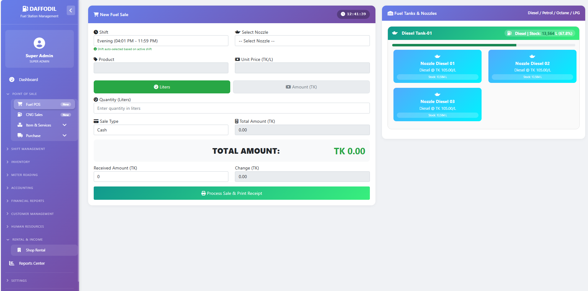

B. CNG Selling Pos Screen:
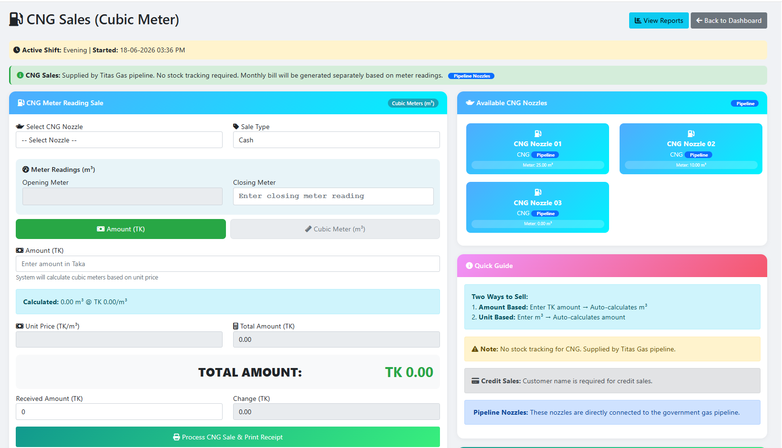

C. Normal ITEM Selling from Fuel Station:

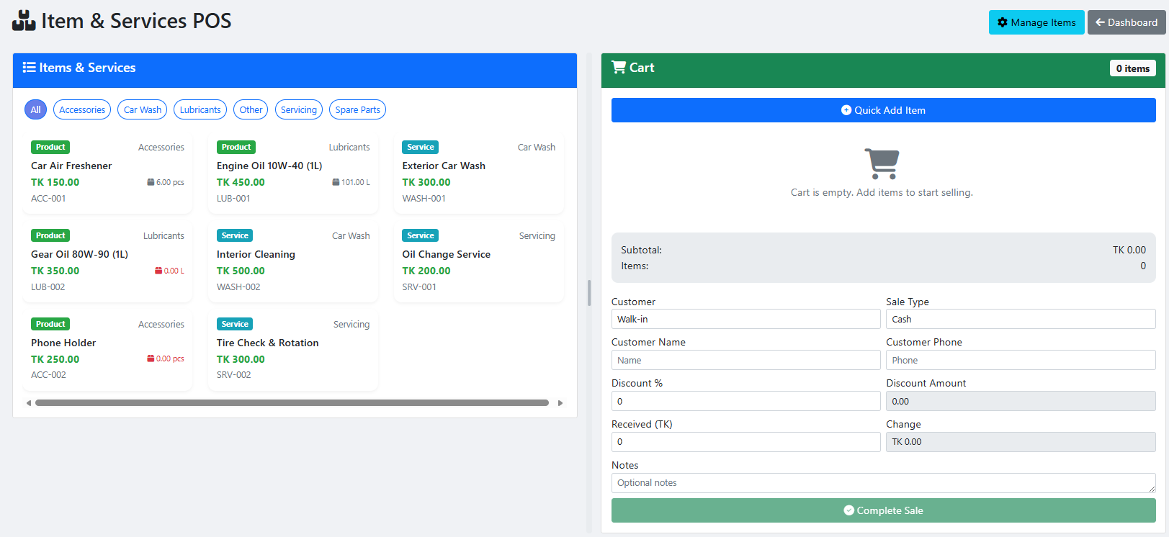
Sections:
- Top Bar: Shift, time, user info
- Left Panel: Sale entry form
- Right Panel: Quick products and nozzles

A. Fuel Sales (Liters)

Step-by-Step Process
Step 1: Select Shift
- Automatically selected based on current time
- Morning: 8:01 AM - 4:00 PM
- Evening: 4:01 PM - 12:00 AM
- Night: 12:01 AM - 8:00 AM
Step 2: Select Nozzle
- Click the "Select Nozzle" dropdown
- Choose fuel nozzle (Diesel, Petrol, Octane, LPG)
- System shows:
  - Nozzle name
  - Product type
  - Available stock in liters
Step 3: Enter Quantity
- Option A - By Liters: Enter liters (e.g., 10 L)
- Option B - By Amount: Enter amount (e.g., 2000 BDT)
Selling by Amount Example:
text
Customer says: "Give me 2000 Taka Diesel"
Step 1: Select "Diesel" nozzle
Step 2: Select "Amount" mode
Step 3: Enter 2000
Step 4: System calculates liters automatically
Step 5: Confirm and process sale
Step 4: Sale Type
- Cash: Immediate payment
- Credit: Customer will pay later
Step 5: Complete Sale
- Click "Process Sale & Print Receipt"
- Receipt prints automatically
- Stock updated immediately

B. CNG Sales (Cubic Meters)

CNG Selling Options
Option | Method | Example
By m³ | Sell by volume | 5 m³ CNG
By Amount | Sell by value | 2000 Taka CNG

Step-by-Step CNG Sale
Step 1: Select CNG Nozzle
- Choose CNG nozzle from dropdown
- System shows available CNG in m³
Step 2: Enter Quantity
- By m³: Enter cubic meters
- By Amount: Enter amount in BDT
CNG Price Example:
text
Price per m³ = 65 BDT
Customer wants 2000 Taka CNG
m³ = 2000 / 65 = 30.77 m³
Step 3: Record Meter Reading
- Opening Meter: Current meter reading
- Closing Meter: After dispensing
- Consumption: Auto-calculated
Step 4: Complete Sale
- Process as regular sale
- CNG inventory updated in m³

C. Normal Item Sales

Types of Normal Items
Category | Examples
Food Items | Snacks, drinks, chips
Automotive | Oil, coolant, wiper blades
Convenience | Cigarettes, matches, etc.

Adding Normal Items
To add new items:
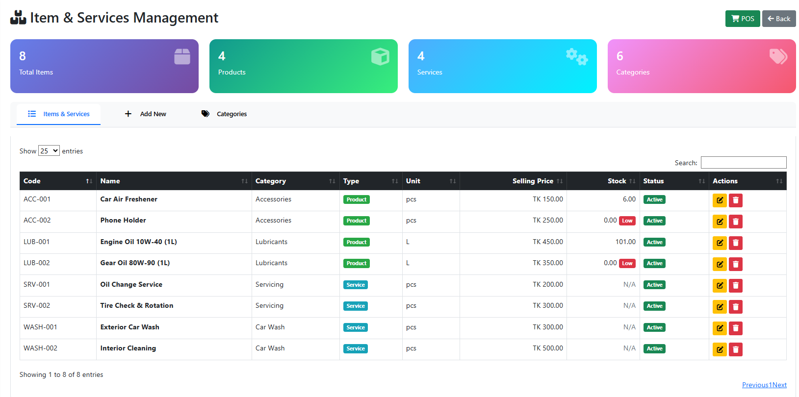
- Go to Settings → Product Management
- Click "Add Product"
- Select "Normal Item" as type
- Enter:
  - Product Name
  - Unit Price
  - Tax Rate (if applicable)
- Click "Save"

Selling Normal Items
Step 1: Select Item
- Click on product in "Quick Products" section
- Or search by name
Step 2: Enter Quantity
- Enter number of units (e.g., 2)
- Price auto-calculates
Step 3: Complete Sale
- Process like regular sale
- Receipt includes item details

D. Amount-Based Selling

How It Works
When a customer says "Give me 2000 Taka fuel":
Step 1: Select Product
- Choose the product (Diesel, Petrol, CNG, etc.)
- Select "Amount" mode
Step 2: Enter Amount
- Enter the amount in BDT (2000)
- System calculates:
  - For Fuel: Liters = Amount ÷ Unit Price
  - For CNG: m³ = Amount ÷ Unit Price
Example Calculations:
text
Diesel (85 BDT/L):
2000 ÷ 85 = 23.53 Liters

Petrol (120 BDT/L):
2000 ÷ 120 = 16.67 Liters

CNG (65 BDT/m³):
2000 ÷ 65 = 30.77 m³
Step 3: Confirm
- System shows calculated quantity
- Customer can see exact liters/m³
- Process sale normally

Benefits of Amount-Based Selling
- Customer Preference: Many customers ask by amount
- Quick Sales: Faster than calculating liters
- Accurate: System calculates exactly
- Transparent: Shows liters/m³ on receipt

CNG Pipeline Management

Overview
CNG is supplied through government pipeline with meter readings. The system tracks:
- Pipeline Incoming: CNG received from government
- Sales Outgoing: CNG sold to customers
- Pipeline Loss: Difference between incoming and outgoing

CNG Meter Reading Process

Daily Meter Reading
Step 1: Record Opening Meter
- At start of day, record pipeline meter reading
- This is the starting point for calculations
Step 2: Record Sales
- Each CNG sale records:
  - Closing meter reading
  - Quantity sold in m³
Step 3: Record Closing Meter
- At end of day, record final meter reading
- Calculate total consumption

CNG Loss Calculation
text
Total Received = Opening Meter Reading
Total Sold = Sum of all CNG sales in m³
Closing Meter = End of day meter reading

Pipeline Loss = Total Received - Total Sold - Closing Meter

CNG Meter Setup
To set up CNG meter:
- Go to CNG Management → Meter Settings
- Enter:
  - Meter Number: Pipeline meter identifier
  - Opening Reading: Current reading
  - Unit: Cubic Meters (m³)
  - Supplier: Government agency
Daily Entry:
- Go to CNG Management → Daily Entry
- Enter:
  - Date
  - Opening Reading
  - Closing Reading
  - Total Received: Calculated from pipeline
- Click "Save"

CNG Reports
Available Reports:
- Daily CNG Report: Day's consumption and sales
- Pipeline Loss Report: Loss analysis
- CNG Sales Report: Sales summary
- Meter Reading History: Track readings over time

Inventory Management

1. Tank Settings

Access: Settings → Tank Settings
Add New Tank:
- Click "Add New Tank"
- Enter:
  - Tank Name: e.g., "Diesel Tank-01"
  - Product: Select from dropdown
  - Capacity: Maximum liters
  - Current Stock: Initial quantity
  - Calibration Factor: For dip stick measurement
- Click "Add Tank"
CNG Storage Notes:
- CNG stored in cylinders, not tanks
- Measured in cubic meters (m³)
- Capacity in m³

2. Stock Management

Access: Inventory → Stock Management
Current Stock Position:
- Shows all products with:
  - Current stock (Liters or m³)
  - Capacity
  - Fill percentage
  - Stock value
Stock Ledger:
- Complete history of all stock movements
- Shows transaction type (Receiving, Sale, Adjustment)
- Reference number for each transaction

3. Fuel Receiving

Access: Inventory → Fuel Receiving
Process Fuel Delivery:
- Select Date
- Enter Supplier Name
- Select Product
- Select Tank
- Enter Expected Quantity
- Enter Actual Quantity
- Shortage auto-calculated
- Enter Unit Price
- Click "Receive Fuel"

4. Leakage & Wastage Management

Access: Inventory → Leakage/Wastage
Process Adjustment:
- Select Tank
- Enter Dip Stick Reading
- Enter Physical Stock
- Variance calculated
- Select Adjustment Type
- Enter Reason Details
- Click "Submit Adjustment"
For CNG Leakage:
- Uses pipeline meter readings
- Loss = Received - Sold - Closing Reading

Accounting Module

1. Chart of Accounts

Access: Accounting → Chart of Accounts
Account Types:
- Assets: What the business owns
- Liabilities: What the business owes
- Equity: Owner's investment
- Income: Revenue from sales
- Expenses: Costs of running business
Special Accounts for CNG:
- CNG Sales Revenue (Income)
- CNG Inventory (Asset)
- CNG Pipeline Loss (Expense)

2. Voucher Entry

Access: Accounting → Voucher Entry
Creating a Voucher:
- Select Voucher Type
- Enter Date
- Enter Narration (description)
- Select Accounts and enter amounts
- Debit = Credit (must balance)
- Click "Save Voucher"

3. Opening Balances

Setting Opening Balances:
- Go to Accounting → Chart of Accounts
- Click "Edit" next to account
- Enter Opening Balance
- Select Balance Type
- Click "Update Account"

Financial Reports

1. Balance Sheet

Format:
text
ASSETS | LIABILITIES & EQUITY
--------------------------------|--------------------------------
Cash Account xxx | Accounts Payable xxx
Bank Account xxx | Loan Payable xxx
Fuel Inventory xxx | Owner's Equity xxx
CNG Inventory xxx | Net Profit/Loss xxx
--------------------------------|--------------------------------
TOTAL ASSETS xxx | TOTAL L & E xxx

2. Profit & Loss Statement
text
INCOME | EXPENSES
--------------------------------|--------------------------------
Fuel Sales xxx | Cost of Goods Sold xxx
CNG Sales xxx | Salary Expense xxx
Rental Income xxx | Utility Expense xxx
Service Income xxx | Pipeline Loss xxx
--------------------------------|--------------------------------
TOTAL INCOME xxx | TOTAL EXPENSES xxx
|
| NET PROFIT/LOSS xxx

3. CNG Specific Reports

Pipeline Loss Report:
- Opening meter reading
- Total received from pipeline
- Total sold to customers
- Closing meter reading
- Unaccounted loss

CNG Sales Summary:
- Daily sales in m³
- Revenue generated
- Average selling price
- Customer distribution

Payroll & HR

1. Employee Management

Access: HR & Payroll → Employees
Add New Employee:
- Click "Add New Employee"
- Enter:
  - Employee ID: Unique identifier
  - Full Name
  - Designation
  - Department
  - Joining Date
  - Basic Salary
  - Phone
  - Address
  - Bank Account No
- Click "Save Employee"

2. Attendance Management

Access: HR & Payroll → Attendance
Daily Attendance:
- Select Attendance Date
- For each employee:
  - Check In Time
  - Check Out Time
  - Status: Present/Absent/Late/Half Day
  - Overtime Hours
- Click "Save Attendance"

3. Payroll Processing

Access: HR & Payroll → Payroll
Generate Payroll:
- Select Month
- Click "Generate Payroll"
- System calculates:
  - Basic Salary
  - Allowances (40% of basic)
  - Overtime Amount
  - Bonus
  - Deductions
  - Net Salary

Rental Management

1. Tenant Management

Access: Rental & Income → Shop Rental
Add New Tenant:
- Click "Add New Tenant"
- Enter tenant details
- Click "Save Tenant"

2. Rent Collection
Record Payment:
- Click "Pay" next to tenant
- Enter payment details
- Click "Record Payment"

Customer Management

1. Customer Ledger

Access: Customer Reports → Customer Ledger
View Customer Ledger:
- Select Customer
- Select Date Range
- Click "View Ledger"

2. Customer Payment

Access: Customer Reports → Customer Payment
Record Customer Payment:
- Select Customer
- Enter Payment Date
- Enter Amount
- Select Payment Method
- Click "Record Payment"

System Settings

1. General Settings

Access: Settings → System Settings → General Settings
Company Information:
- Company Name
- Phone
- Email
- VAT Registration No
- Address

2. Shift Schedule

Access: Settings → Shift Schedule
Set Shift Timings:
Shift | Start | End
Morning | 08:01 AM | 04:00 PM
Evening | 04:01 PM | 12:00 AM
Night | 12:01 AM | 08:00 AM

3. User Management (Super Admin Only)

Access: Settings → System Settings → Users
Manage Users:
- Add New User
- Edit User
- Reset Password
- Activate/Deactivate

Reports & Export

1. Sales Reports

Access: Reports Center → Sales Reports
- Daily Sales Report
- Monthly Sales Report
- Export to Excel
- Export to CSV

2. CNG Reports

Access: Reports Center → CNG Reports
- CNG Sales Summary
- Pipeline Meter Reading Report
- CNG Loss Report

3. Inventory Reports

Access: Reports Center → Inventory Reports
- Stock Valuation Report
- Leakage Report

Troubleshooting

Common Issues & Solutions

1. CNG Meter Reading Error
Issue: Meter reading not updating
Solutions:
- Check opening and closing readings
- Verify readings are in m³
- Contact pipeline supplier

2. Amount-Based Calculation
Issue: Amount calculation incorrect
Solutions:
- Check unit price is correct
- Verify selling price per unit
- Check for decimal precision

3. POS Not Loading
Issue: POS page not loading
Solutions:
- Check internet connection
- Clear browser cache
- Refresh the page (F5)
- Logout and login again

4. Stock Not Updating
Issue: Stock levels not updating
Solutions:
- Check if sale completed successfully
- Check stock ledger for errors
- Manually update stock if needed

Error Messages
Error | Meaning | Solution
"Insufficient stock" | Not enough product | Receive stock before selling
"Invalid meter reading" | Reading format error | Check meter reading format
"Please select a product" | No product selected | Select product from dropdown

Quick Reference

Product Units
Product | Unit | Symbol
Diesel | Liters | L
Petrol | Liters | L
Octane | Liters | L
CNG | Cubic Meters | m³
LPG | Liters | L
Normal Items | Units | Pcs

Selling Modes
Mode | Description
Quantity | Sell by volume/units
Amount | Sell by value in BDT

Shift Timings
Shift | Start | End
Morning | 08:01 AM | 04:00 PM
Evening | 04:01 PM | 12:00 AM
Night | 12:01 AM | 08:00 AM

Glossary of Terms
Term | Definition
POS | Point of Sale
CNG | Compressed Natural Gas
Nozzle | Fuel dispensing unit
Tank | Storage container
m³ | Cubic Meter (CNG measurement)
Pipeline Loss | Unaccounted CNG loss
Meter Reading | CNG pipeline measurement
Amount-Based Selling | Selling by value (BDT)

Support

Contact Information
- System Administrator: [Contact details]
- Support Email: [Support email]
- Support Phone: [Support phone]

When Reporting Issues
- Describe the problem clearly
- Take screenshots if possible
- Note error messages
- Mention time of occurrence
- Provide browser and version

Document Version: 1.0
Last Updated: June 2024
Prepared For: Daffodil Software Limited

